Model Development Phase Template

Date | 24 June 2026
Team ID | SWUID2026218531
Project Title | Credit Card Approval Prediction
Maximum Marks | 4 Marks

Initial Model Training Code, Model Validation and Evaluation Report
The initial model training code is showcased through a screenshot. The model validation and evaluation report includes classification reports, accuracy, and confusion matrices for multiple models, presented through respective screenshots.

Initial Model Training Code:
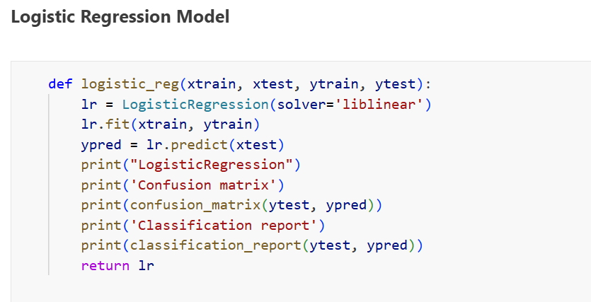

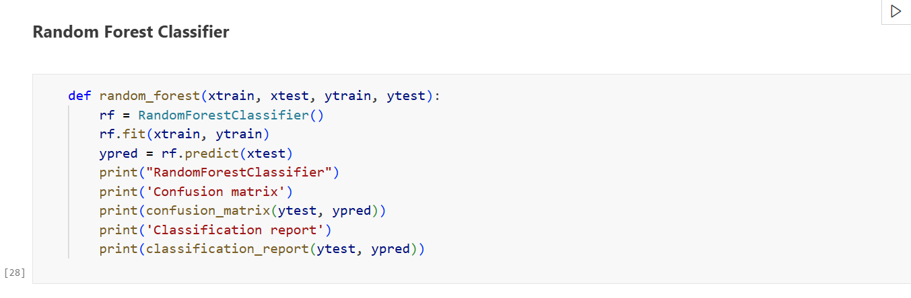

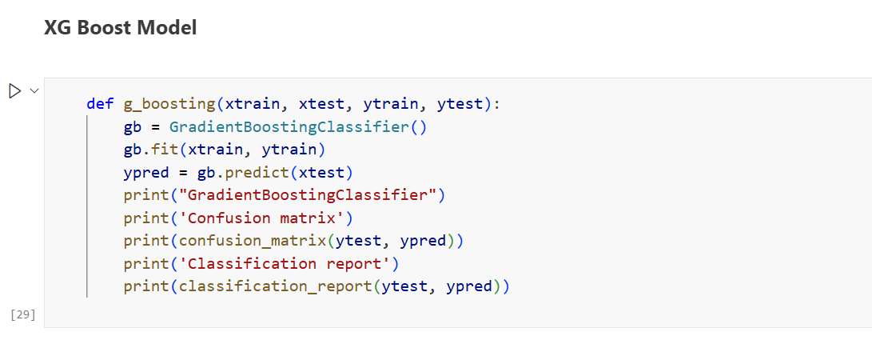

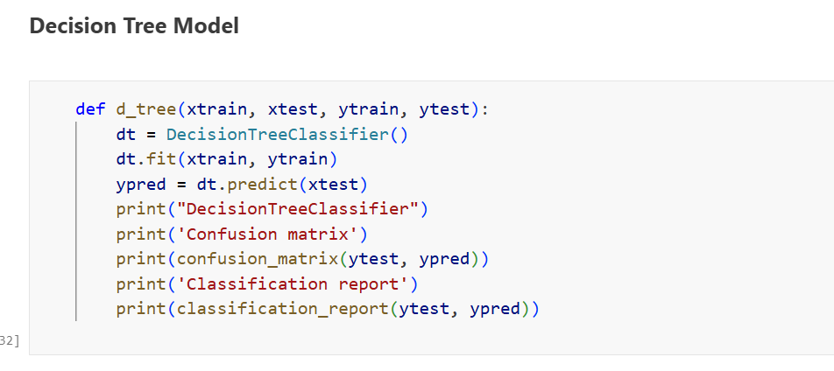

Model Validation and Evaluation Report:
Model | Classification Report | Accuracy | Confusion Matrix
Logistic Regression | 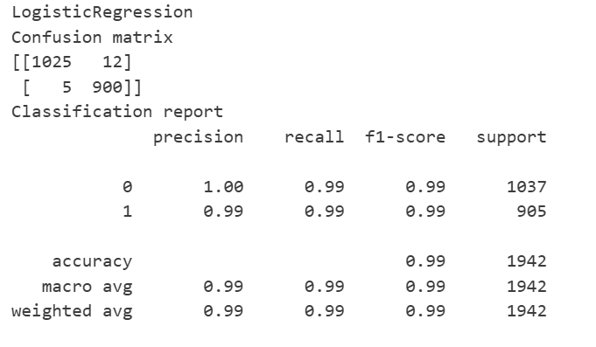 | 99% | 
Random Forest Classifier | 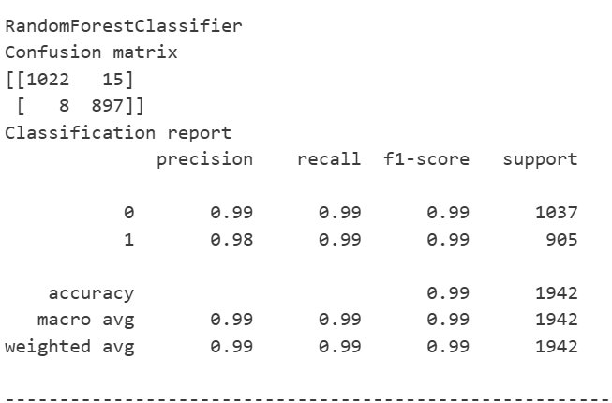 | 98% | 
Gradient Boosting Classifier | 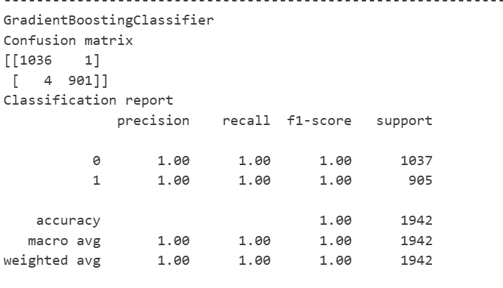 | 100% | 
Decision Tree Classifier | 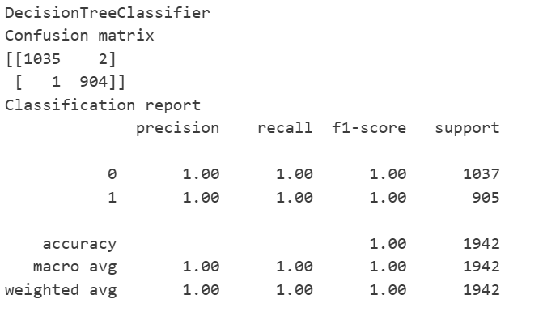 | 100% | 

